Doppler-Free Spectroscopy

Rosalyn Chan

York University

PHYS4160

Cody Storry

16th November 2021

**Introduction**

The Doppler-free spectroscopy experiment demonstrates the general structures of the rubidium atom with reference to quantum numbers n, L, S, J and F. The origin of cross-over peaks and lamb dips are defined and described as well as determining the frequency difference of the rubidium hyperfine splitting of the 5P3/2 state.

**Section 6.3.2: Pump beam alignment**

**Think about it:**

Given the selection rules, the allowable transitions must satisfy $∆L=1$ and $∆F=-1,0, +1$. Therefore, the origin of Lamb dips we would expect to observe for the 85Rb to states would be from ${5S}_{1/2}F=3$ to ${5P}_{3/2}F=2$, ${ 5S}_{1/2}F=3$ to ${5P}_{3/2}F=3$, ${ 5S}_{1/2}F=3$ to ${5P}_{3/2}F=4$ and also exactly halfway in between every pair of allowable transitions of ${5S}_{1/2}F=3$ to ${5P}_{3/2}F=2$, ${ 5S}_{1/2}F=3$ to ${5P}_{3/2}F=3$, ${ 5S}_{1/2}F=3$ to ${5P}_{3/2}F=4$.

**Section 6.3.3: Background subtraction**

**Think about it:**

The background subtracted beam needs to be pass through the Rubidium cell for this experiment as this would result in the background beam being doppler broadened as well. Hence, when the background subtraction is performed, this would very nicely produce a visual where we are able to clearly see the hyperfine splitting.

**Data Analysis**

Oscilloscope traces for four Doppler-broadened absorption features of both the laser passing through the cell and the background beam is recorded with range frequency at position 5 and different amplitude settings for each of the four Doppler-broadened absorption features.

**(a) Part 1:**

The rate at which the laser is scanning its frequency back and forth is of range frequency at position 5. The inverse of this rate is the amount of time the laser takes to undergo a full scan cycle. Half of this value will be the amount of time the laser takes to ramp up. In order to find the spacing of two peaks in units of laser frequency, the spacing between two peaks is determined in seconds and divide it by the number of seconds it takes for the full ramp up and then multiplying this ratio into the scan amplitude calibration.

Amount of time the laser takes to undergo a full scan cycle: 0.01s ± 0.00005s

Amount of time the laser takes to ramp up: 0.005s ± 0.000025s

The uncertainty of time is taken to be 0.00005s, that is by taking the lowest division of the oscilloscope scale.

**87Rb F=1 to F’=0,1,2:**

Amplitude setting:3.5

Amplitude calibration at setting 3.5: 6.514× ${10}^{9}$ Hz

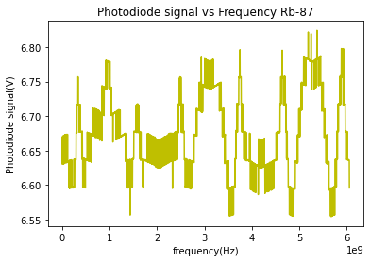

Figure 1: Lamb dips of 87Rb F=1 at amplitude setting 3.5.

**85Rb F=2 to F’=1,2,3:**

Amplitude setting:1.5

Amplitude calibration at setting 1.5: 4.545× ${10}^{9}$ Hz

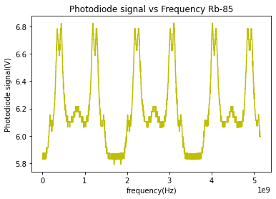

Figure 2: Lamb dips of 87Rb F=2 at amplitude setting 1.5.

**85Rb F=3 to F’=2,3,4:**

Amplitude setting:0.5

Amplitude calibration at setting 0.5: 1.970× ${10}^{9}$ Hz

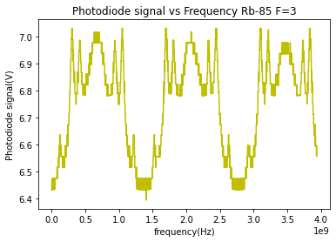

Figure 2: Lamb dips of 85Rb F=3 at amplitude setting 0.5.

**87Rb F=2 to F’=1,2,3:**

Amplitude setting:1.0

Amplitude calibration at setting 1.0: 3.939× ${10}^{9}$ Hz

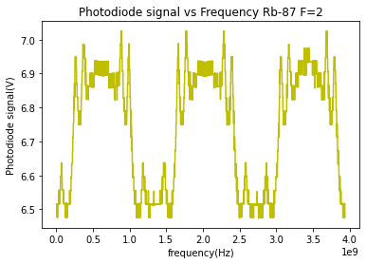

Figure 4: Lamb dips of 87Rb F=2 at amplitude setting 1.

**Part 2:**

The peaks are labelled by its corresponding excited state F number. The crossover peaks are labelled with a pair of numbers which denotes which two excited states contributes to their formation. For instance, a peak labelled as (2,3) is the crossover between F’=2 and the F’=3 excited states.

**87Rb F=1 to F’=0,1,2**



Figure 5: Lamb dips of 87Rb F=1 at amplitude setting 3.5.

No lamb dips can be seen in 87Rb F=1 to F’=0,1,2

**85Rb F=2 to F’=1,2,3**

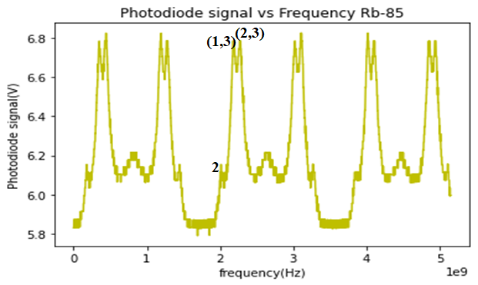

Figure 6: Lamb dips of 85Rb F=2 at amplitude setting 1.5.

The origin of the lamb dips would be from 5S1/2 F=2 to 5P3/2 F’=2.

**85Rb F=3 to F’=2,3,4**

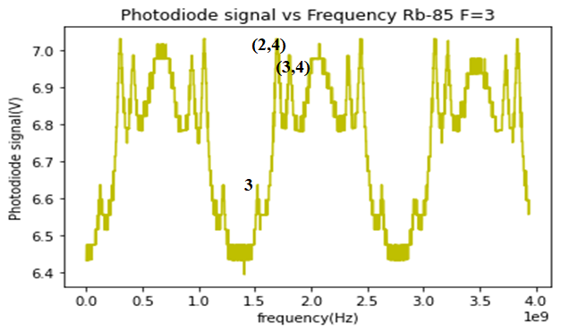

Figure 7: Lamb dips of 85Rb F=3 at amplitude setting 0.5.

The origin of the lamb dips would be from 5S1/2 F=3 to 5P3/2 F’=3.

**87Rb F=2 to F’=1,2,3**

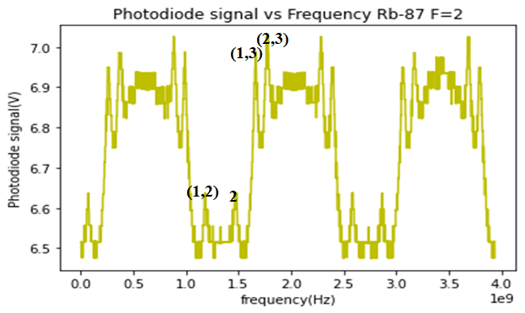

Figure 8: Lamb dips of 87Rb F=2 at amplitude setting 1.0

The origin of the lamb dips would be from 5S1/2 F=2 to 5P3/2 F’=2.

**Part 3:**

The hyperfine splitting of 5 $P_{3/2}$ F states is determined by computing the difference of two lamb dips in seconds, and dividing by the amount of time the laser took to ramp up and multiplying that ratio into the amplitude calibration.

The uncertainty of time is taken to be 0.00005s, that is by taking the lowest division of the oscilloscope scale.

**87Rb F=1 to F’=0,1,2**

Amplitude setting: 3.5

Amplitude calibration: 6.514× ${10}^{9}$ Hz

No lamb dips can be seen in 87Rb F=1 to F’=0,1,2, therefore the hyperfine splitting can not be carried out as one requires to identify the lamb dips correctly.

**85Rb F=2 to F’=1,2,3**

Amplitude setting: 1.5

Amplitude calibration: 4.545× ${10}^{9}$ Hz

Time between two lamb dips (s), $t_{1}$: 0.0138s-0.00936s = 4.44× ${10}^{-3}s ±0.00005s$

Time of the laser going through a single ramp, $t_{2}$: 0.005s ± $0.000025s$

Ratio of time, $t_{r}$: $\frac{4.44×{10}^{-3}}{ 0.005}=0.888$

Uncertainty of the time ratio $δ_{t}=\sqrt{\left(\frac{δ_{t_{1}}}{t_{1}}\right)+\left(\frac{δ_{t_{2}}}{t_{2}}\right)}=\sqrt{\left(\frac{0.00005}{4.44×{10}^{-3}}\right)+\left(\frac{0.000025}{ 0.005}\right)}=0.0123$

$⇒$ time ratio, $t_{r}$: $0.888$ ± $0.012$

⸫ Hyperfine splitting, H: $\left(\frac{4.44×{10}^{-3}}{0.005} ±0.012 \right)$ (4.545× ${10}^{9})$ Hz = (4.036×

**85Rb F=3 to F’=2,3,4**

Amplitude setting: 0.5

Amplitude calibration: 1.970× ${10}^{9}$ Hz

Time between two lamb dips, $t_{1 }$: 0.01672s-0.01128s = 5.44× ${10}^{-3}s ±0.00005s$

Time of the laser going through a single ramp, $t_{2}$: 0.005s ± $0.000025s$

Ratio of time, $t_{r}$: $\frac{5.44×{10}^{-3}}{ 0.005}=1.088$

Uncertainty of the time ratio $δ_{t}=\sqrt{\left(\frac{δ_{t_{1}}}{t_{1}}\right)+\left(\frac{δ_{t_{2}}}{t_{2}}\right)}=\sqrt{\left(\frac{0.00005}{5.44×{10}^{-3}}\right)+\left(\frac{0.000025}{ 0.005}\right)}=0.011$

$⇒$ time ratio, $t_{r}$: $1.088$ ± $0.011$

⸫Hyperfine splitting: $\left(\frac{5.44×{10}^{-3}}{0.005} ±0.011\right)$ (1.970× ${10}^{9})$ Hz = (2.143×

**87Rb F=2 to F’=1,2,3**

Amplitude setting: 1.0

Amplitude calibration: 3.939× ${10}^{9}$ Hz

Time between two lamb dips, $t_{1 }$: 0.0156s-0.01244s = 3.16× ${10}^{-3}s$

Time of a laser going through a single ramp, $t_{2}$: 0.005s

Ratio of time, $t_{r}$: $\frac{3.16×{10}^{-3}}{ 0.005}=0.632$

Uncertainty of the time ratio $δ_{t}=\sqrt{\left(\frac{δ_{t_{1}}}{t_{1}}\right)+\left(\frac{δ_{t_{2}}}{t_{2}}\right)}=\sqrt{\left(\frac{0.00005}{3.16×{10}^{-3}}\right)+\left(\frac{0.000025}{ 0.005}\right)}=0.016$

$⇒$ time ratio, $t_{r}$: $0.632$ ± $0.012$

⸫ Hyperfine splitting: $\left(\frac{3.16×{10}^{-3}}{0.005}± 0.012\right)$ (3.939× ${10}^{9})$ Hz = (2.489 ± 0.047) × ${10}^{9}Hz$

**Discussion and Conclusion:**

The hyperfine splitting of the 5P3/2 F states are found to be (4.036× for 85Rb F=2, (2.143× for 85Rb F=3 and (2.489 ± 0.047) × for 87Rb F=2. The hyperfine splitting of 87Rb F=1 could not be computed as no lamb dips were able to be identified. It is also important to note here that the hyperfine splitting found here are at an order of GHz which is much higher than the expected value at an order of Mhz. One of the many possibilities is due to the fact that not all six peaks were able to be produced during the whole process of the experiment. As a matter of fact, technical issues and complications were also ran upon during the duration of the experiment which might have contributed to the data being somewhat unreliable.

**Appendix A:**

|  |  |  |
| --- | --- | --- |
| Rubidium states | Oscilloscope traces | Amplitude setting |
| 87Rb F=1 to F’=0,1,2 |  | 3.5 |
| 85Rb F=2 to F’=1,2,3 |  | 1.5 |
| 85Rb F=3 to F’=2,3,4 |  | 0.5 |
| 87Rb F=2 to F’=1,2,3 |  | 1.0 |